**Manual VM Build Fulfillment Overview**

Manual VM provisioning is one of the responsibilities of the VMWare team. These requests usually come into the VMWare Remedy queue as a task from a parent Work Order owned by the Project Manager leading the project. The task typically includes a link to the design document for the project in the Notes section. In some rare cases, it may be found on the task as an attachment. If a design document is not included, the project manager or requester should be contacted to provide it.

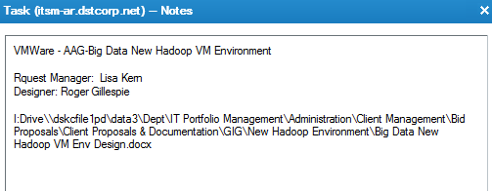

**Pre-Execution Validation and Analysis**

It is important to note that before starting building virtual machines for a given project/design, the project manager should be contacted to ensure the design has been approved by the appropriate stakeholders and that it is ready for execution. This will help prevent potential waste of time and resources on re-work activities.

Once confirmation is received, a pre-execution analysis should be conducted to determine compute resource availability. For example, is there enough host capacity on the intended hosting environment for the new workload? Is there enough storage available? If not, can the storage team provide it and how soon? Is the new workload being provisioned on existing VLAN(s) or does new VLAN(s) need to be defined in UCS and vCENTER? Has the VLAN(s) been trunked by Network Service?

To properly manage expectations, it is critical to carefully conduct this analysis before committing to a delivery date. A helpful practice is to review the design document before the final design to delivery transition meeting typically scheduled by the project manager.

**Execution Phase**

It is crucial for the VMWare team to start executing on the delivery of Manual Build VMs as quickly as possible once the design has been approved and transitioned for delivery. This is because other task completions such as Windows/Linux, DB, and Application are dependent on the VMWare team’s completion of VM builds. Do not provision any server classified as Cloud Build. Cloud Build servers are provisioned by the Guest OS admins - Windows/Linux using the cloud life-cycle management(CLM) tool.

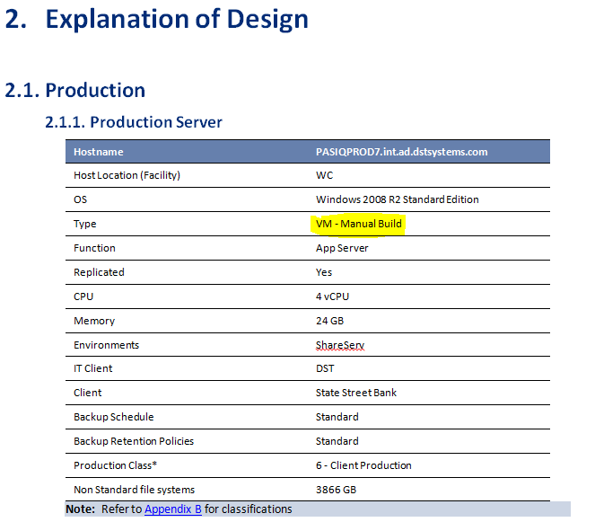

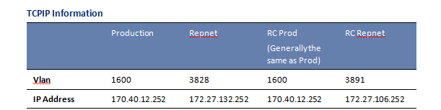

This is a typical manual build server request. In this case, a Windows 2008 R2 Standard server is to be built in the Windows ShareServ cluster on 2-site replicated storage from WC to IC. Ensure that VLAN port groups exist both on the production and DR side as part of the analysis. If they don’t exist, they must be defined both in UCS and vSphere under an approved standard change control.

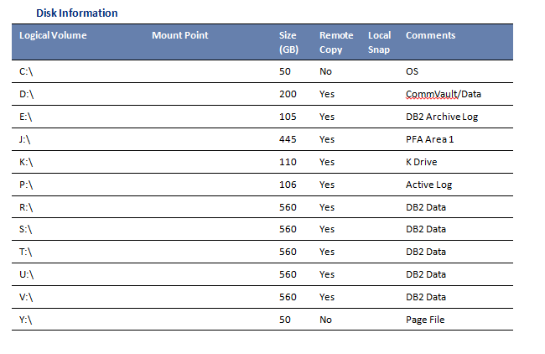

A typical disk layout for a mid to large size virtual server looks like this. Consider splitting the VMDK volumes across multiple SCSC controllers for a VM this size. Four to five VMDKs per SCSI controller is a reasonable number. Use Thick Eager Zero VMDK formatting for large DataBase servers. Thick Lazy Zeroed for other types of workloads is acceptable. DO NOT use thin provisioning formatting in any of the production hosting environments.

Per our current standard, thin provisioning should be used **only** in the HETD hosting environment.

Consider placing large VMs that expand across multiple datastores on their own dedicated datastore cluster leaving storage DRS disabled.

*Upon completion of a task, it is a good practice to provide completion notes in the work details area of the task alerting the project manager that the VMWare team portion of the design has been completed and the VMs are ready for the Guest OS admin.*